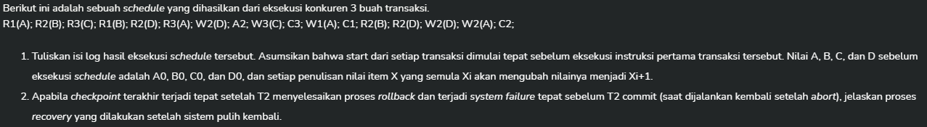

1.

|  |  |
| --- | --- |
| Schedule | Log |
| R1(A) | <T1 start> |
| R2(B) | <T2 start> |
| R3(C) | <T3 start> |
| R1(B) |  |
| R2(D) |  |
| R3(A) |  |
| W2(D) | <T2,D,D0,D1> |
| A2 | <T2,D,D0>  <T2 abort> |
| W3(C) | <T3,C,C0,C1> |
| C3 | <T3 commit> |
| W1(A) | <T1,A,A0,A1> |
| C1 | <T1 commit> |
| R2(B) | <T2 start> |
| R2(D) |  |
| W2(D) | <T2,D,D0,D1> |
| W2(A) | <T2,A,A1,A2> |
| C2 | <T2 commit> |

2.

|  |  |
| --- | --- |
| Log | Aksi |
| <T1 start> | 1. Scan backward log sampai ke checkpoint terakhir |
| <T2 start> |
| <T3 start> |
| <T2,D,D0,D1> |
| <T2,D,D0> |
| <T2 abort> |
| <checkpoint UL = T1,T3> | 1. dari checkpoint, scan forward sambil mengupdate UL sampai akhir |
| <T3,C,C0,C1> | C = C1 |
| <T3 commit> | Hapus T3 dari UL sehingga UL = {T1} |
| <T1,A,A0,A1> | A = A1 |
| <T1 commit> | Hapus T1 dari UL sehingga UL = {} |
| <T2 start> | Masukkan T2 ke UL sehingga UL = {T2} |
| <T2,D,D0,D1> | D = D1 |
| <T2,A,A1,A2> | A = A2 |
| Fail | 1. scan backward pada transaksi yang ada di UL yakni T2 |
| <T2,A,A1> | Counter <T2,A,A1,A2> |
| <T2,D,D0> | Counter <T2,D,D0,D1> |
| <T2 abort> | Hapus T2 dari UL sehingga UL = {} |
|  |  |
|  |  |
|  |  |
|  |  |
|  |  |
|  |  |
|  |  |
|  |  |
|  |  |
|  |  |
|  |  |